New Light through Old Windows
Cataloguing the Archive of Abbott and Company

Final Project Report

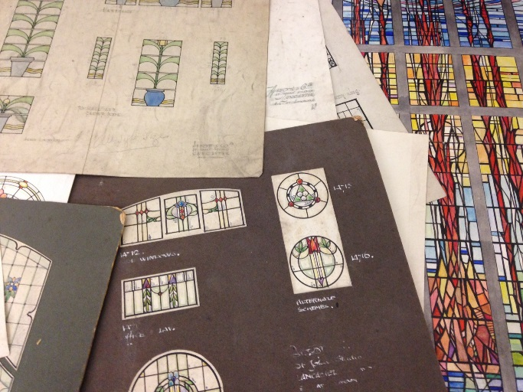

Project Summary

Thanks to a grant of £3000 from the Business Archives Council, Lancashire Archives has been able to undertake a project to catalogue the archive of Abbott and Company, stained glass manufacturers of Lancaster. Beginning in October 2016 and finishing in mid-February 2017, the project ran to time and to budget, delivering the promised outcomes and having some other unintended positive consequences! The archive is now better understood and far more accessible than it was. We are now developing plans which will put it at the centre of some exciting community engagement work.

The Business and its Archive

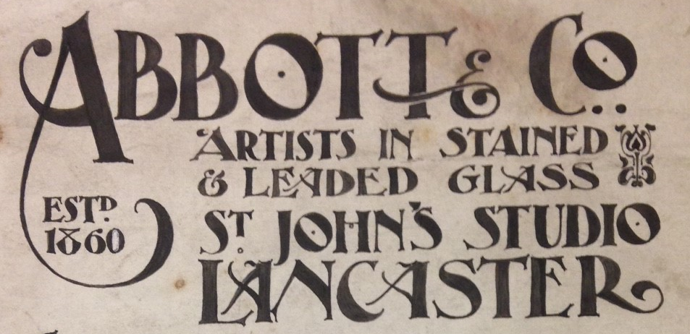

Founded in 1860 as plumbers and glaziers, initially by William Abbott, the company appears to have moved more into stained glass around 1890 under the management of his son James Hartley Abbott. The firm produced tens of thousands of pieces of both secular and ecclesiastical stained glass, many of which can still be seen in churches, hospitals, town halls, pubs and country houses, in Lancashire, across the UK and overseas.

At the beginning of the project, the archive comprised:

- Watercolour designs – used to present an initial design to the client; produced in pen and ink and watercolour; usually including design numbers; some are signed (c. 1909-1960s; extent: c. 800 boards and 2-3000 individual designs)
- Cartoons – pencil drawings of design details (early 20th century; extent: c. 200)
- Cutline drawings – full size designs used for cutting the glass shapes; produced in black and white, sometimes annotated and arranged by design number (c. 1909-1960s; extent: c. 2000 bundles)
- Day books – these give design number, customer name and address, description of work and are the most comprehensive record of the work undertaken by the company, including designs which may not have eventually been produced (1920s-1960s; extent: 138 volumes)
- Financial ledgers – a mix of day books, cash books and ledgers; extent 15 volumes; also including workmen's time books recording hours worked and wages paid (1899-1948); extent 13 volumes
- Correspondence – extent: 3 boxes (1920s-1960s)

Our Approach

We recruited a freelance archivist whose objective was to deliver against the commitments we made in our bid. She completed limited reappraisal (a very small amount of duplicated or low value material was disposed of) and the arrangement and description of the archive, except the very large series of designs which were listed by volunteers under her supervision. The BAC grant was spent entirely on paying the Archivist; all additional costs were funded by the Friends of Lancashire Archives.

Key Outcomes

Our commitment | What we delivered
To produce a multi-level catalogue for the collection which conforms to ISAD (G) and includes a detailed administrative history and information about how to find information about a specific commission | This was completed and is now available in LANCAT - http://archivecat.lancashire.gov.uk/calmview/ - our online catalogue (1717 entries) and will shortly be available on the National Archives Discovery catalogue
Liaise with colleagues in Lancashire Museums and curators and archivists elsewhere to ensure the inclusion in the catalogue of comprehensive information about other relevant museum and archive collections | This happened and the information about related material is included in the collection level entry of the catalogue
Work with the Lancashire Archives Conservation team to improve the packaging of the collection | All the collection has been re-packaged except the cutline drawings
Supervise 2 volunteers who will list the watercolour designs in detail and digitise a representative sample to be included in the online catalogue | In the end, 10 volunteers were involved, who played a large part in the success of the project, contributing over 100 hours of their time
Develop a spin-off project to index the day books by customer/building, which will begin by Jan 1 2017 and be completed before Jul 1 2017. Volunteers with an interest and enthusiasm have already voiced an interest in participating. This project will be run by the Friends of Lancashire Archives | This is underway in slightly modified form – we are working back from the surviving designs to the day books rather than the other way around. This change was prompted by what we found out during the cataloguing process about the various numbering systems used by Abbots.

Other outcomes

- Newspaper coverage of the award led to 2 deposits of stained glass related archives.

- A useful working relationship has developed with Jasmine Allen, the curator at the stained glass museum:

  - Jasmine kindly hosted a visit from our archivist and provided lots of background information and advice. We also discovered that the Abbott and Company kiln (similar to the one below) now lives at the museum.
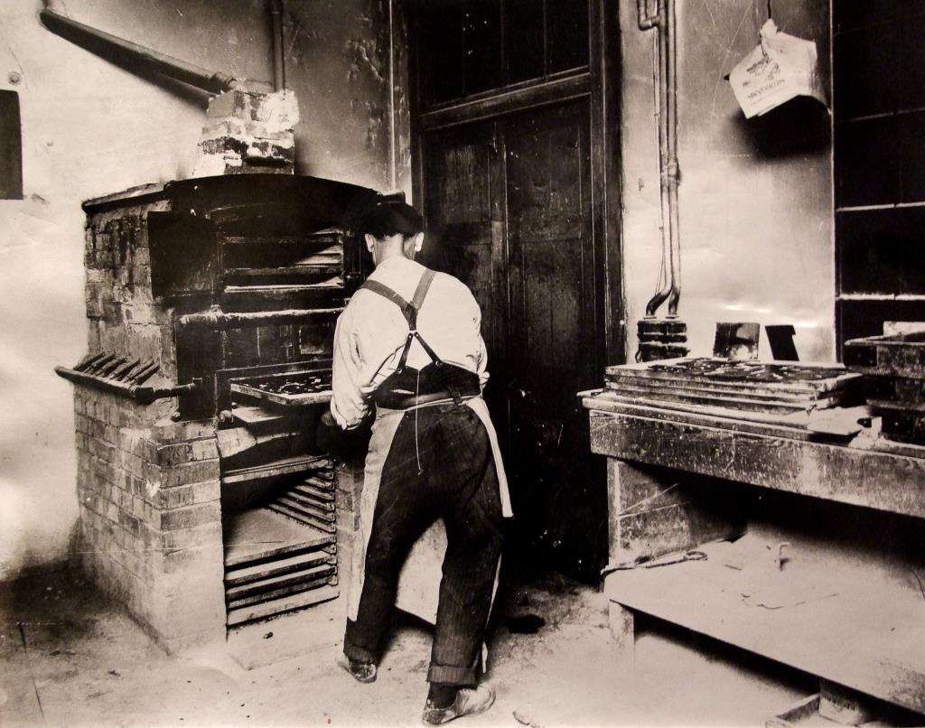

  - A small number of Abbotts designs have been transferred to us from the Stained Glass Museum as a direct result of the project

- Outreach
  - 2 embroidery groups, having seen the newspaper coverage of the award, have booked a session to come in and look at the designs in the collection.
  - There will be a talk on the collection at Lancaster Museum, 9 Jun 2017
  - There will be a whole day's event (still in the planning stage!) on 25 Nov 2017 dedicated to the Abbott and Company archive and linked to the “Explore your Archives” campaign.
  - Next year we want to make sure our stained glass collections are part of the "Light up Lancaster Festival" which takes place in the city every autumn.

